Project Overview

5 June 2020 | Andrei Florian

# Idea Improvements

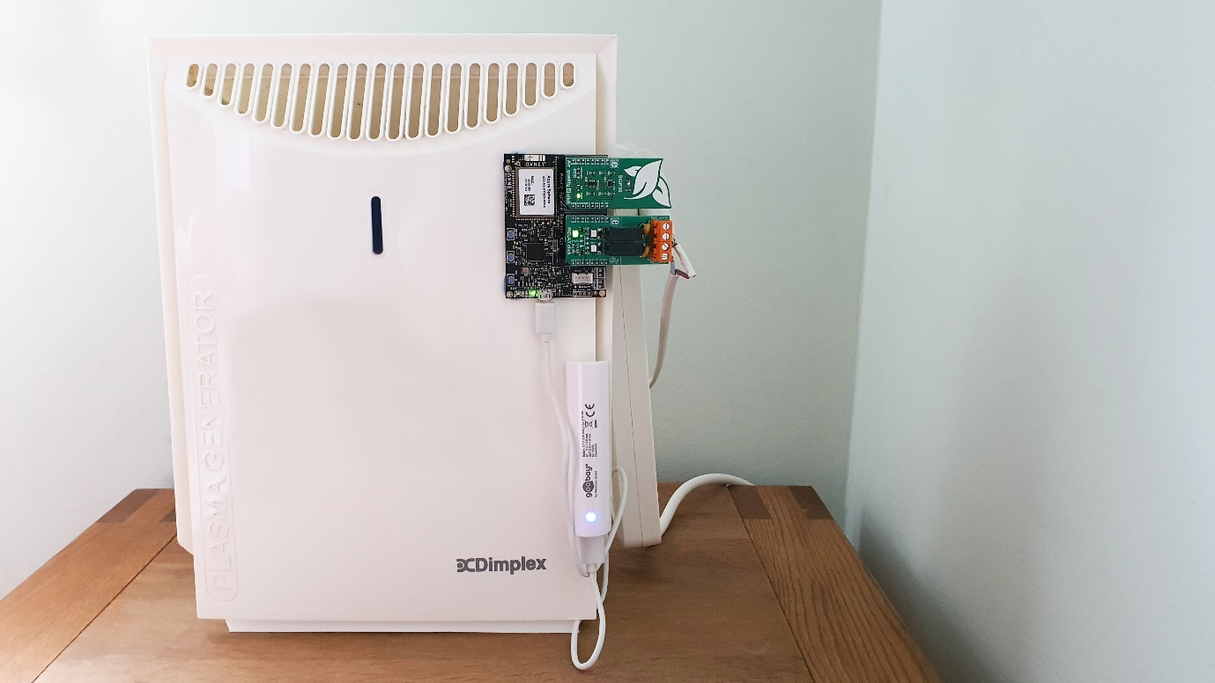

Many changes have been made to the idea to facilitate the development of the project. These changes are listed below.

## Data Collection

There was a **misunderstanding** when purchasing the MikroE clickboard, the device does not measure the amount of Carbon monoxide in the atmosphere but **carbon dioxide**. The data collected by the device hence does **not include a carbon monoxide reading**.

Because of this, the carbon **monoxide alarm mode was removed** from the project as this data is not available. **Temperature and humidity data are not collected anymore**. This is because the **onboard temperature sensors are heavily influenced by the heating of the device** as it is running, and an external sensor could not be added due to the lack of available ports and resources.

## The addition of the fan

Because **carbon dioxide is also harmful** to organic life when in great quantities and can have effects similar to the ones posed by excessive carbon monoxide, a **new mode** has been added to the device where it can **control a fan** (if mounted) which would absorb the **carbon dioxide and ventilate it out** of the room.

This is facilitated by the **presence of 2 modules in the MikroE clickboard** allowing 2 separate devices to be controlled. Note that the fan is not included in this debut of the project but can be added as an extra by the end user as there is code support for it.

## The Purifier now turns on automatically

This implementation was made because the previous idea where the user would have to enable the purifier to run manually **defeated the purpose of an automatic air purifier** and made the implementation seem more like a traditional purifier. On top of this, the extraction of this feature meant that the code was faster to develop.

## Deprecating the Alerts in the Backend

After a long attempt and documentation, it became apparent that **there was no way to implement data alerts in PowerBi because the data was flowing into the report through a Power Bi dataset which does not support data alerts.**

This issue can be overcome through the sending of the data into a database and then querying it from there. This can be included in a future release of the project.

# Project Overview

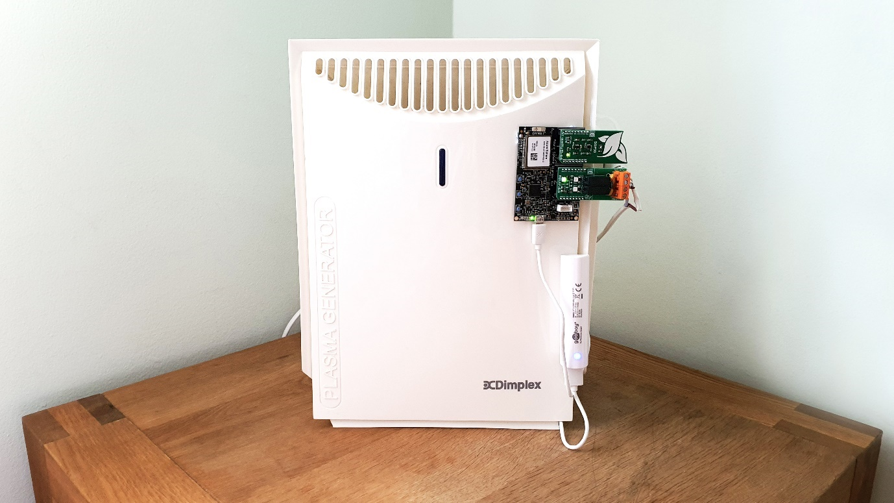

People spend most of their day at home, they wake up, go to work, then come back and stay until the next day. We all try to beautify our home environment through the addition of sometimes extravagant furniture and flowers. But we do not pay that much attention to the air inside our home.

Studies show that indoor air we breath in most of the day **is 3 to 4 times more polluted than the air outside our house.** This refers to the **higher amount of carbon dioxide** as well as **volatile organic compounds (VOCs) which are harmful for our lives.**

Studies show that the **presence of carbon dioxide in excessive amounts can lead to a lower level of concentration**, this is because a higher level of carbon dioxide would replace the oxygen that should be present in the air reducing the oxygenation of the brain leading to reduced brain function.

VOCs also have an impact on human health. Studies show that **over 30% of households have excessive levels of VOCs.** These can lead to problems such as **difficulty breathing, and lengthened exposure can lead to nasal cancer.**

So, what can we do to make our home environment healthier? **Air purifiers** can filter the VOCs out of the air easily, but there is a catch; the cost of modern air purifiers can be quite high. But we do not want to have an air purifier that would run all the time because that would **waste energy**. We need our devices to be **connected to the internet and run without the need for us to press buttons and plug them in.**

**Smart air purifiers** are the solution! These devices purify the air automatically whenever excessive impurities were detected. But the **cost of implementing solutions like this are excessive**, and on top of that, there is **very little information given to the user about air quality.**

So, what about carbon dioxide? Well, simple **ventilators and fans** can redirect the impurities outside but running them all day can **use up a significant amount of energy**. So, what if you could automate both an air purifier and a fan to ensure that the air quality indoors is optimal at all times?

This is where IntlAir comes in, IntlAir is a device powered by the Azure Sphere board which monitors the indoor air quality by reading the TVOC and carbon dioxide levels and turning on the air purifier and/or the fan, respectively. The device also monitors barometric pressure to ensure that the atmosphere is optimum.

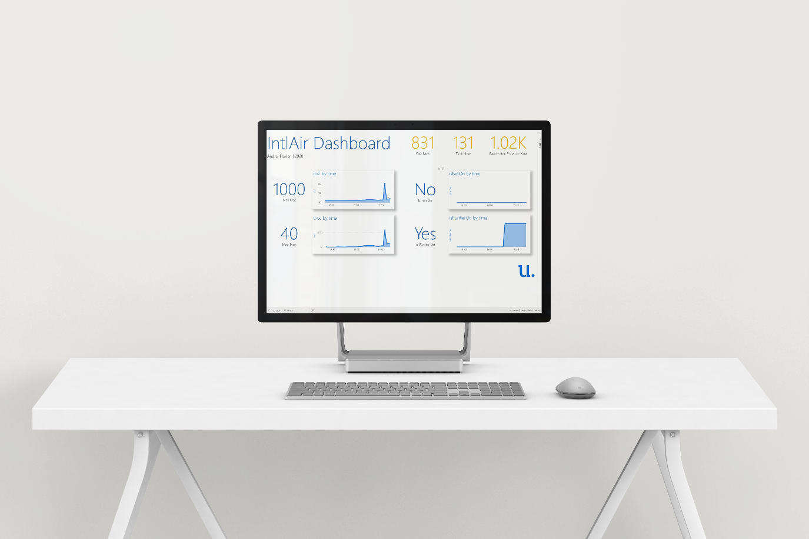

This way, any fan system and purifier can be modernised and brought into the age of IoT in minutes, no need to purchase new, expensive systems. IntlAir can significantly reduce the amount of energy used by these devices and provides the user with a comprehensive dashboard and application where they can visualise both the air quality in the home, and when the purifier was running.

This gives the user full control over the data and ensures that the air in their home is always clean. Bring your home into the future with a smart, cost-effective implementation.

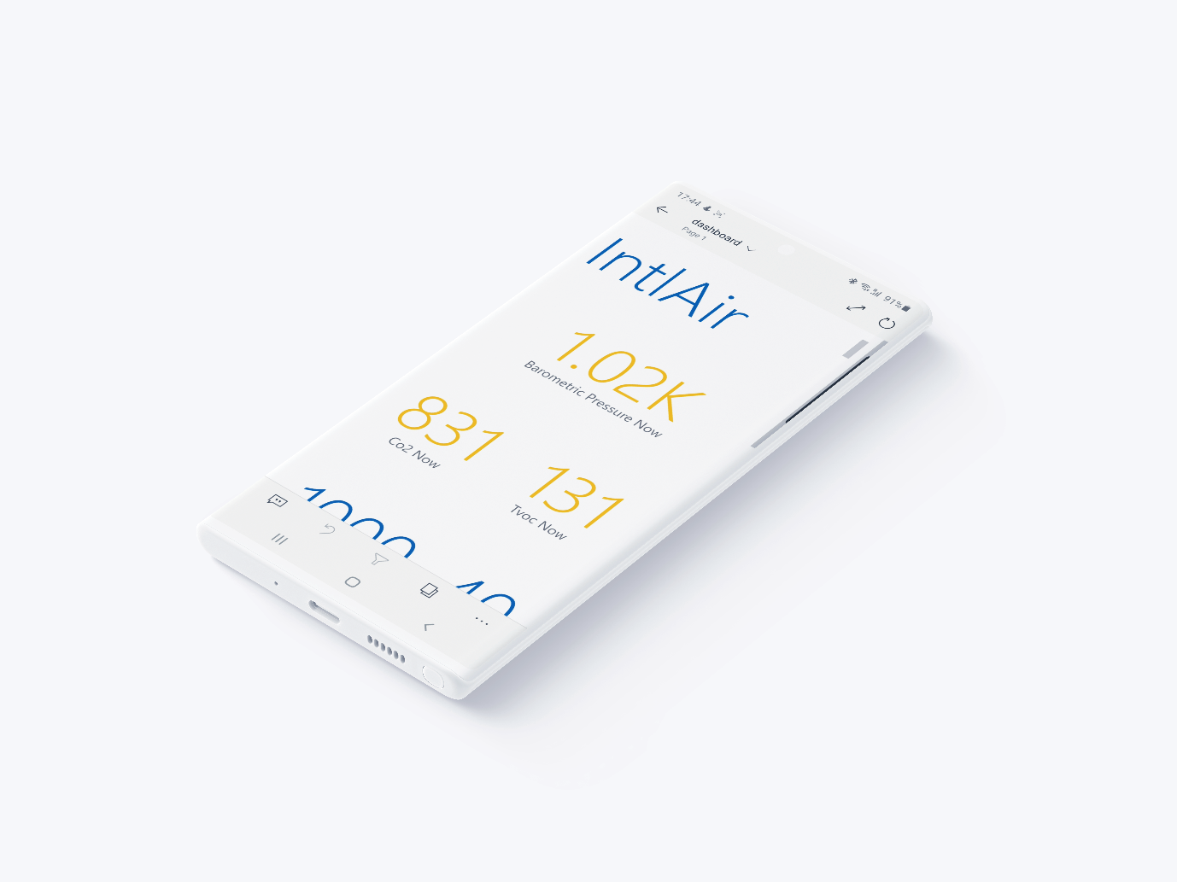

## Some more about TVOCs and Carbon Dioxide

As previously mentioned, it is important to monitor the levels of these compounds in the air. Sadly, **because of the cost of solutions that monitor these parameters, most homes will not be equipped with such sensors.**

The term TVOC refers to the **Total amount of Volatile Organic Compounds** in the atmosphere. There are many VOCs such as **ethanol and butanol**. The TVOC level is **calculated by counting the concentration of a few of these VOCs together** getting the total level VOCs in the atmosphere.

Both TVOCs and CO2 are calculated in either particles per billion (ppb) or **particles per meter (ppm)**. These measurements are the same and represent the **concentration** (amount) of these compounds in the atmosphere **in respect to 1 billion air particles**.

After conducting research in the field, I managed to put together some tables with the effects of different concentrations of TVOCs and carbon dioxide on the health of the inhabitants, these are shown below:

### Co2 Levels

|  |  |
| --- | --- |
| 250-400ppm | Normal background concentration in outdoor ambient air |
| 400-1,000ppm | Concentrations typical of occupied indoor spaces with good air exchange |
| 1,000-2,000ppm | Complaints of drowsiness and poor air. |
| 2,000-5,000 ppm | Headaches, sleepiness and stagnant, stale, stuffy air. Poor concentration, loss of attention, increased heart rate and slight nausea may also be present. |
| 5,000 | Workplace exposure limit (as 8-hour TWA) in most jurisdictions. |
| >40,000 ppm | Exposure may lead to serious oxygen deprivation resulting in permanent brain damage, coma, even death. |

### TVOC Levels

|  |  |  |  |
| --- | --- | --- | --- |
| **Source** | **Concentration** | **Associated Period of Exposure** | **Health Effect(s)** |
| **Based on sensory irritation** |  |  |  |
| California Environmental Protection Agency (EPA) | 44 ppb | 1 hour | Eye and airway irritation |
| Health Canada | 100 ppb | 1 hour | Eye irritation |
| National Institute for Occupational Safety and Health | 100 ppb** | 15 minutes | ** |
| Occupational Safety  and Health Administration | 750 ppb | 8-hour PEL-TWA | Cancer and skin/eye/ respiratory irritation |
| World Health Organization | 81 ppb | 30 minutes | Sensory irritation |
| World Health Organization | 100 ppb | Short- and long-term | Sensory irritation |
| **Based on respiratory and asthma-like symptoms** |  |  |  |
| Agency for Toxic Substances and Disease Registry | 40 ppb  30 ppb  8 ppb | Daily:1-14 days  15-364 days  > 1 year | Respiratory |
| California EPA | 7 ppb  7 ppb | 8-hour  annual average | Respiratory symptoms  Respiratory symptoms |
| Health Canada | 40 ppb (target) | 8 hours | Respiratory symptoms in children |
| **Based on cancer risk** |  |  |  |
| National Institute for Occupational Safety and Health | 16 ppb | 8 hours | Nasal cancer |
| Occupational Safety  and Health Administration | 750 ppb | 8-hour PEL-TWA | Cancer and skin/eye/ respiratory irritation |
| World Health Organization | 100 ppb | Long-term | Nasal cancer |

After analysing this data, I set the values at which the fan and purifier would turn on at 1,000ppm of CO2 for the fan and 40ppm of TVOCs for the purifier. This way the room can be cleaned if the concentration of impurities exceeds this limit.

## Frontend

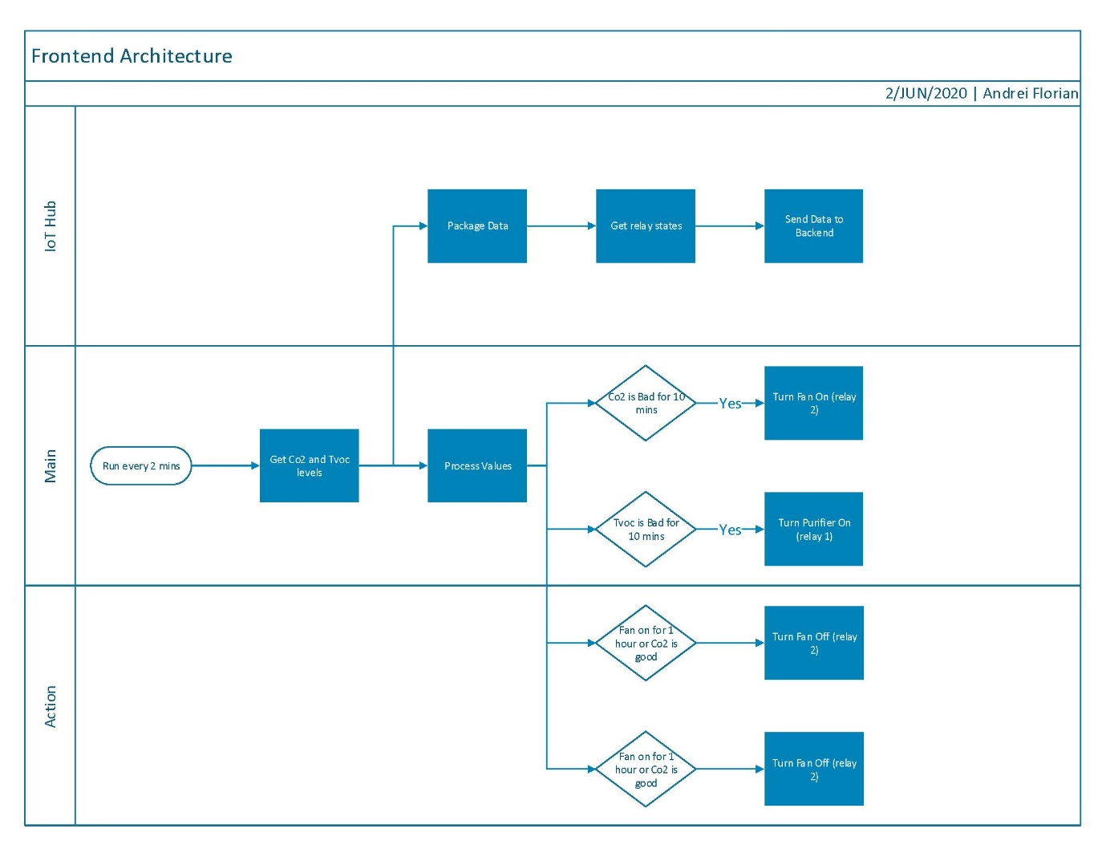

The frontend of the project refers to the **device that controls the purification system**. The diagram above shows this process. As seen above, the device will **turn on every 2 minutes** (sleeping in between).

The device will **collect the TVOC and Co2 data** from the click modules attached and will then **process it** to see if the values are abnormal. If this is the case, the **relay controlling the fan and the one controlling the purifier will be toggled.** The device will also pack all this data and send it to the cloud.

### Managing the Relays

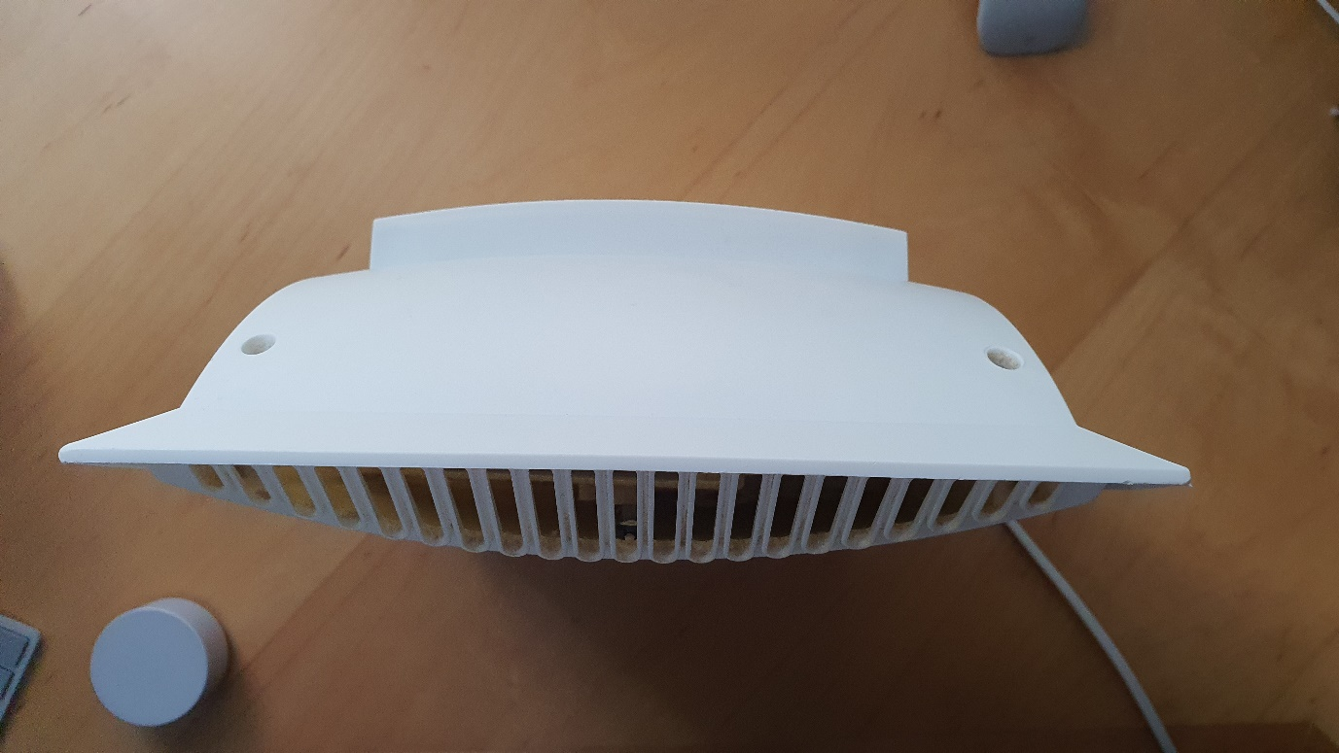The system was designed to turn on the fan and/or the purifier **until the air is clean**. But to prevent the device from running the purifier excessively. **It will turn off after 1 hour of running if the air is still not clean.**

The device will **prevent the purifier/fan from turning on for one hour** to let **the air in the room circulate** and if the air is still dirty afterwards, the purifier/fan will turn on again.

### The Azure Sphere

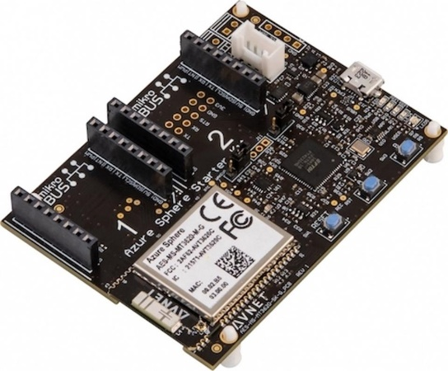

I find the Azure Sphere development board a great device to work with. It is true that it takes a bit longer to get started with it than other platforms but since its debut, support, libraries and tutorials have poured online and now it is easy to prototype an application on the board. Avnet’s iteration is especially great because of the addition of the MikroE bus pins which makes developing so much faster and easier. A shout out to Walter Coan for the great tutorials on Hackster and element14!

### Security

Because this is a home automation project, I believe that **security is of upmost importance** to ensure that the application is running smoothly and undisturbed by outside sources. The Azure Sphere device is as secure as it gets when it comes to IoT. From the **Pluton chip** ensuring that the device’s code can only be modified by users with access to the spe**cificity needed in the app manifest**, this device will ensure that the application is running smoothly and securely.

## Backend

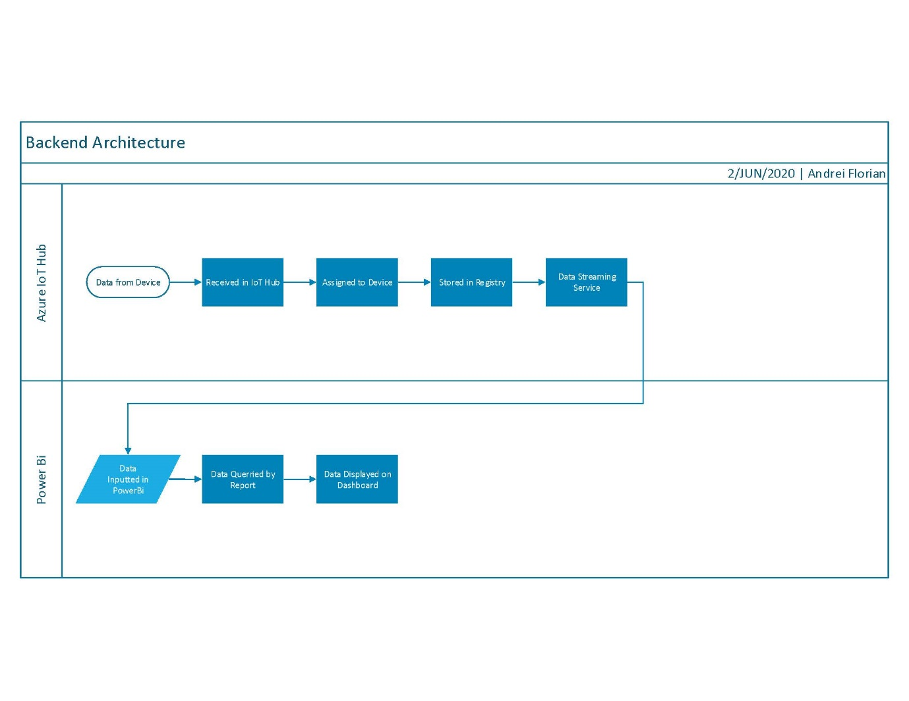

The backend of the project refers to the **cloud infrastructure implemented to deal with the telemetry data** sent by the device as well as the **Power Bi dashboard** which the end user will be able to access from anywhere.

### Automatic connection and Integration with the Azure Sphere

The Azure Sphere is limited to connecting to the Azure Cloud which **ensures data is sent in a safe environment.** I personally use the Azure cloud for my projects, honestly mainly because of the brilliant interface so it is great to see that the Azure Sphere makes the connection easier.

### Message Routing

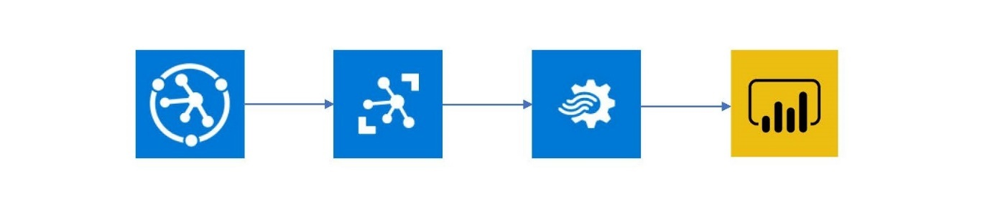

A **DPS (device provisioning service) connects the device to the IoT Hub**. This feature allows for the **connection of thousands of devices if needed without human interference** making connection seamless.

The messages are then placed in the IoT Hub. They are then extracted by a **Stream Analytics job** and forwarded into a **Power Bi dashboard and mobile app**. The data is displayed live in the dashboard.

### The Dashboard and App

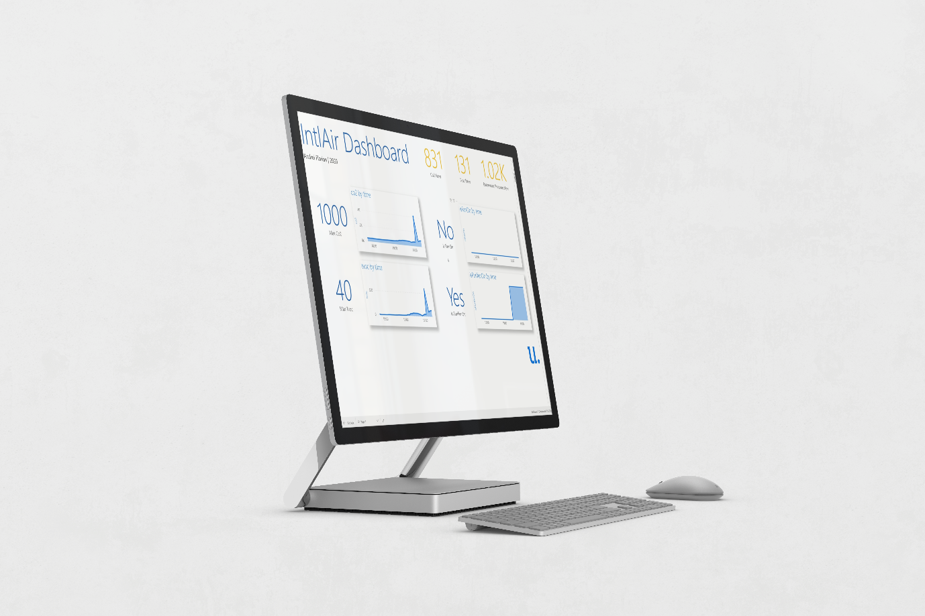

Aesthetically pleasing UI is essential for a modern application targeted at individuals. A dashboard which shows the user all the information they need in an orderly and beautiful fashion is just as important as the data collected by the device.

I leveraged the powerful capabilities of **Power Bi** to develop a stunning dashboard which is available to the user in the cloud so they can see the data from anywhere at any time. I also converted it into a mobile application using **Power Bi’s powerful phone layout** so that users can carry their data in their pockets being able to check the air quality at work, on the bus, and everywhere in between.

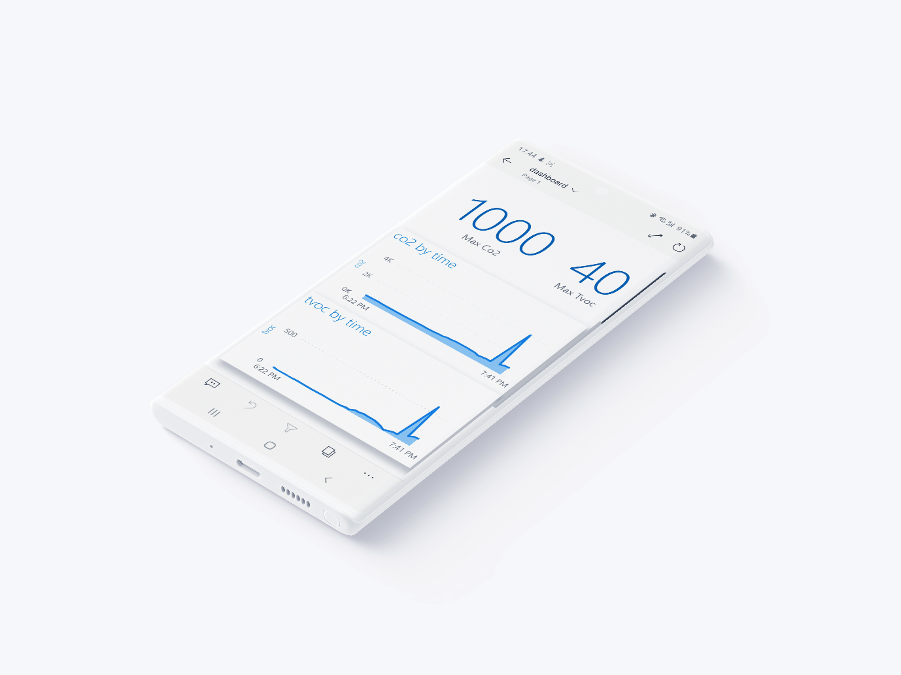

The dashboard shows the user the **current levels of TVOCs and Co2** in the home as well as the **barometric pressure**. This data is also shown on **graphs over time**. The user can also see within the app **if the purifier and/or fan is running** even if they are at work putting the data in the user’s hands.

## Going Further

I want to note that this project can still work if only an air purifier or a fan is connected and not both.

While developing this project. I kept notes of ways in which this project can develop further in next versions. Below is a list of developments of the project:

* **Adding alerts** so that the user can know when the purifier/fan is turned on and off and if the air is not clean in the home.
* **Storing the data in Cosmos DB** to allow multiple applications to use it in the backend if needed.
* **Azure Functions can be used** to route messages from the IoT Hub into the Power Bi report. This will dramatically reduce the cost of development.

# Market Research

Market research was conducted for this project to gain an insight into the users that would use it as well as the competition for the product.

## Target Market

The target market for this product is described under the following headings:

Age The product can help **people of any age** but is aimed at **families** because they will tend to care more about the air quality in their home because of their children.

Economic Background The device is aimed to **middle and lower-class households** because of its low cost and because it is easily implementable.

Lifestyle The product is aimed at people that **care about their health** indoors and want to live a healthy lifestyle.

## Competition

The main competition that has been encountered when researching similar products was a range of air purifiers known as “smart air purifiers”. These devices turn on automatically when they sense impurities in the air.

Although these devices already exist, their **price point starts from €100 for the cheapest models.** These products also offer a **very small amount of control** over the purification of the air which is not appropriate.

## Unique Selling Point

There are multiple advantages and USPs that this product has over others that already exist in the market. These are listed below.

* **Cheaper than most of these devices**
* **Any air purifier can be turned into a smart one**
* A dashboard well designed providing the user with more information than typical models would
* **Azure Sphere’s security integration**

## User Persona

Zara and James are a couple with 2 children. They have recently read about the importance of air quality and are wondering if they can improve the air quality in their home. They searched for smart air purifiers online, but the expense of a quality product is too high. Instead, they decide to purchase a normal purifier and use IntlAir to turn it into a smart air purifier saving money and energy. They have also connected their pre-existing fan system to the device to further save energy.

# Project Conduct

This section will walk through the steps needed to construct the project and some tips on getting everything together.

## Getting everything, you need

Ok, let us get started by ensuring that we have all the components we need to create this project. Below is the **BOM needed**. **Please make sure that you purchase the correct versions of the MikroE modules.**

* [Azure Sphere MT3620 development board](https://ie.farnell.com/avnet/aes-ms-mt3620-sk-g/starter-kit-arm-cortex-a7-cortex/dp/3106884)
* [MikroE Air Quality Click 4](https://www.mikroe.com/air-quality-4-click)
* [MikroE Relay Click 1](https://www.mikroe.com/relay-click)
* Power bank

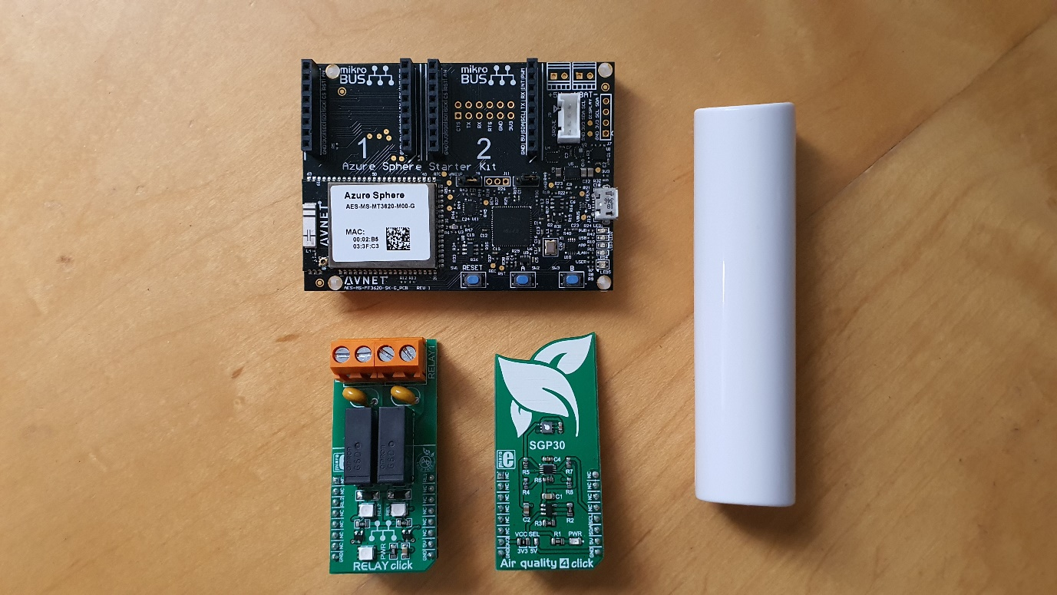

## Some prerequisites before we get started

Before we can start with this project there are a **couple of steps that have to be taken to set up our development environment**. You will be needing **a PC and an Azure Sphere device** to get started so we can set things up.

1. Download [Visual Studio](https://visualstudio.microsoft.com/) (VS Code works too) and ensure you download the C++ development environment.
2. Ok, the next thing we need to do is download the Azure Sphere SDK. You can get it [here](https://docs.microsoft.com/en-us/azure-sphere/install/install-sdk).
3. Please note that you must download both the Azure Sphere SDK and the Extension for it. You will now need to download the extension from [this page](https://docs.microsoft.com/en-us/azure-sphere/install/development-environment-windows).
4. The next thing we will need to do is claim the device to our tenant. You will need to create one first using your Microsoft account. Everything you need is at [this link](https://docs.microsoft.com/en-us/azure-sphere/install/claim-device), ensure to read through it all.
5. Great, and lastly, we need to connect the device to your WiFi network. [This link](https://docs.microsoft.com/en-us/azure-sphere/install/configure-wifi) will guide you through the process.

## Getting everything connected.

Ok, so the next thing we need to do is **get the MikroE clickboards mounted on the device**. Well, you just have to **attach them on the pins**. Make sure that you **connect the first socket to the Air Quality click and the second socket to the Relay Click**. It should look like this:

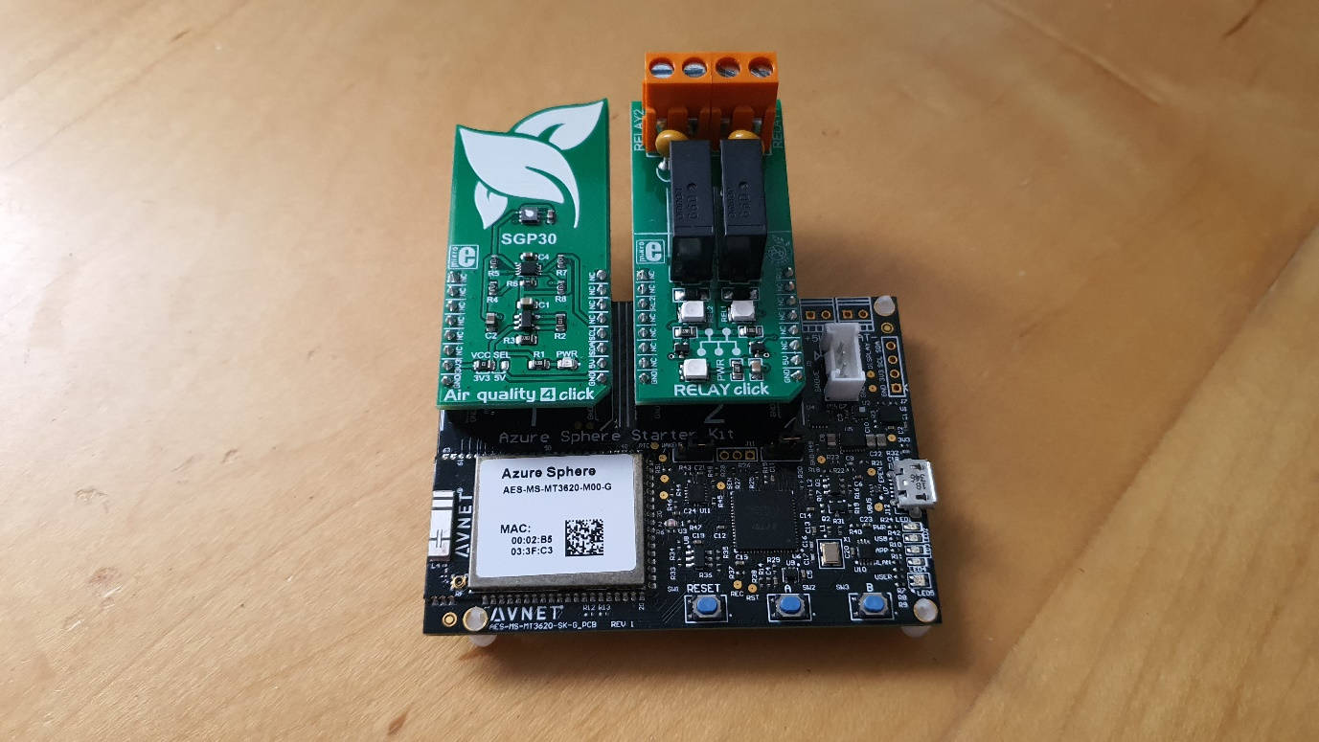

## Moving on with the Relay

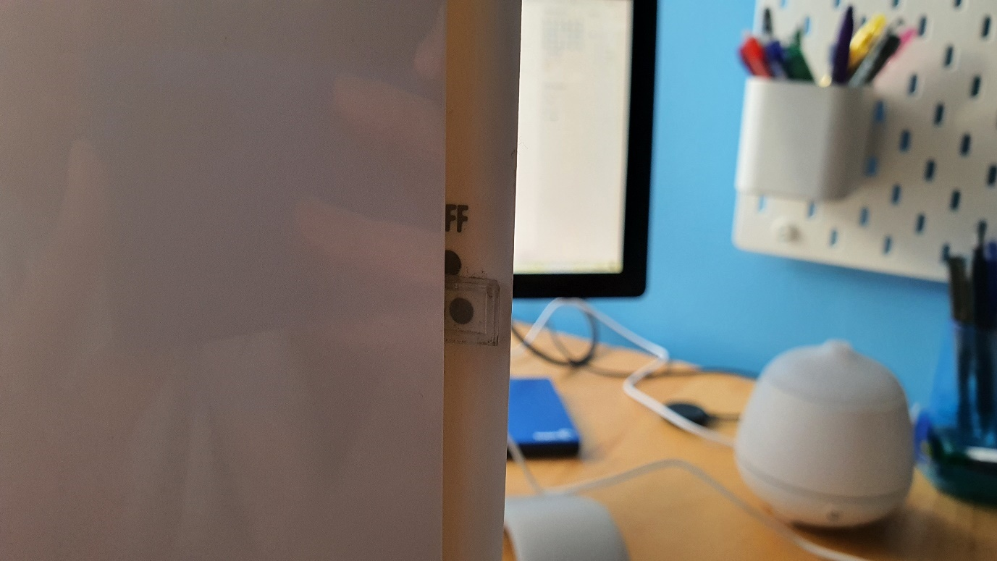

Now that we have the components ready, we must **attach our fan and purifier to the relay** to be able to control them. Now there is a small caveat; **the devices have to be able to turn on automatically when they are plugged in**, the purifier I had used a switch so **if I would set it to on, it would automatically start running if I plugged it in.** Something like this is needed for the project to work. Please look at the table below to see which devices must be connected to each relay.

|  |  |
| --- | --- |
| Relay 1 – Terminals 1, 2 | Air Purifier |
| Relay 2 – Terminals 3, 4 | Fan |

Ok, so we have to cut the power cable running from the plug to the device to reveal the wiring to get started.

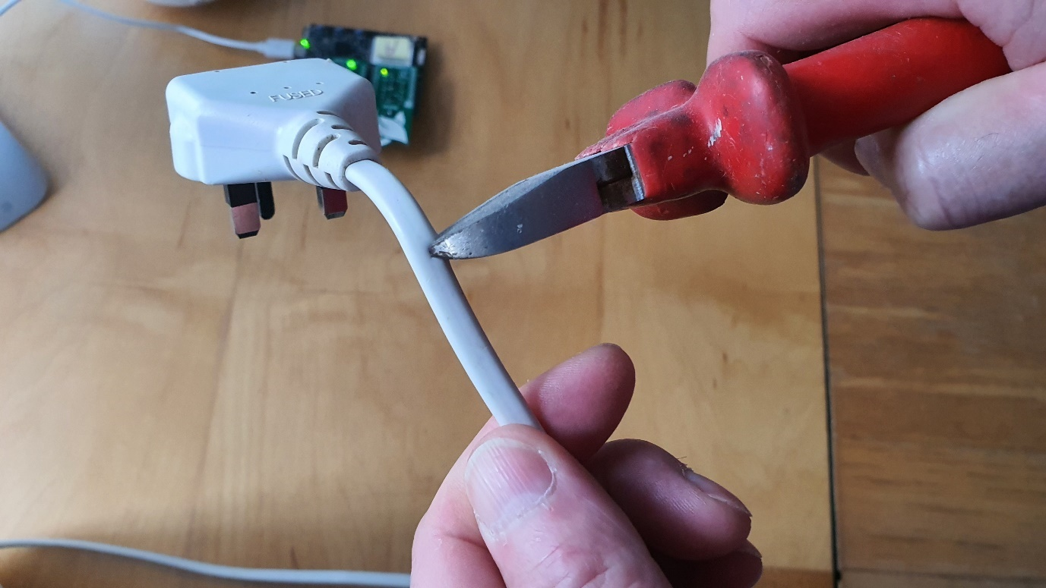

Now we will need to connect the ground wires together again but keep the power ones separated. We now need to take the relay click and connect the ends of the power wire to the terminals of the device.

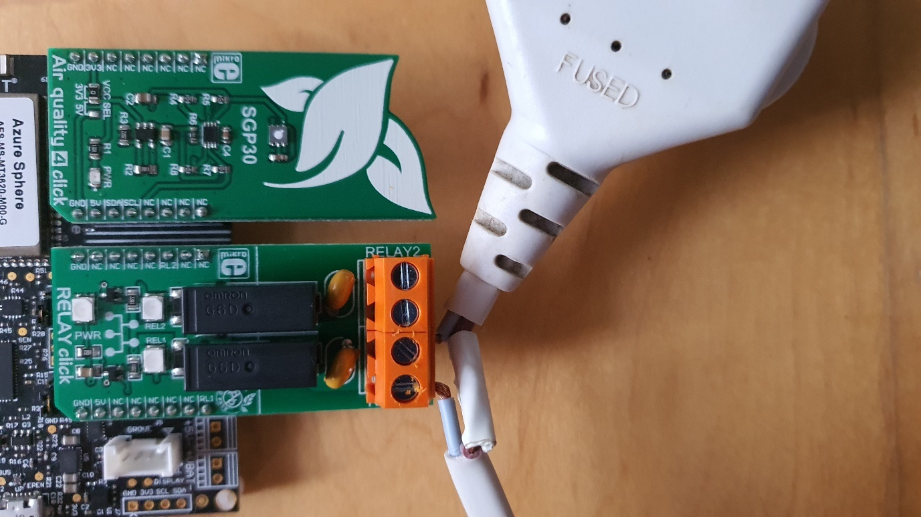

**Make sure to insulate the wires after you do this** to ensure the safety of the device. Repeat the same process for the fan ensuring that the wires are in the correct place. Once that is done, you are ready to move on.

## Working in the backend, getting the IoT Hub Ready

For this section, **you will need to have a free Microsoft Azure Account**. You can get your account for free [here](https://azure.microsoft.com/en-us/free/search/?&ef_id=Cj0KCQjw_ez2BRCyARIsAJfg-kv440AJYtRGKVjWP28QJishm9oW1ZAgR9AdOXwo1o6ytGZpZMlHhq8aAldLEALw_wcB:G:s&OCID=AID2000084_SEM_Cj0KCQjw_ez2BRCyARIsAJfg-kv440AJYtRGKVjWP28QJishm9oW1ZAgR9AdOXwo1o6ytGZpZMlHhq8aAldLEALw_wcB:G:s&dclid=CLqrn_W57ekCFWSN7QodH8oDGA) and also get $200 credits to get you started.

Please follow the tutorials below to get your IoT Hub, Device Provisioning Service and Certificates ready. **It is** **very important to note that although the tutorial uses the S1 tier IoT Hub, you can use the F1 tier which is free of cost and achieves the same thing in our case.**

1. Use [this link](https://docs.microsoft.com/en-gb/azure/iot-dps/quick-setup-auto-provision) to set up your IoT Hub and DPS. **Do not do the Cleaning up section at the end.**
2. Finally, follow the tutorial at [this link](https://docs.microsoft.com/en-us/azure-sphere/app-development/setup-iot-hub) to get your Azure Sphere connected to your hub

## Moving on with the Streaming Job

We will be using a streaming job to extract the data from our IoT Hub as it is sent and relay it on to the Power Bi dataset we will be using later. Please note that **this can also be done by using an Azure Function which is cheaper**. The first section will walk through using Azure Functions and the second will use a Streaming Job.

### Using Azure Functions

I personally used Stream Analytics for this project because it is easier to use. I did find two tutorials that show you how to get up and running and then how to connect the IoT Hub and then Power Bi. **Note that you will have to adapt the code yourself to run.**

1. Set up the function and connect the IoT Hub by following [this tutorial](https://azure.microsoft.com/nl-nl/blog/how-to-use-azure-functions-with-iot-hub-message-routing/).
2. Connect Power Bi by adapting the code to include some from [this tutorial](https://www.linkedin.com/pulse/stream-data-power-bi-from-azure-function-9-lines-code-van-valkenburg).

### Using Stream Analytics Job

Ok, so if we are going to use the Stream Analytics job, the first thing to do is op**en our Azure Portal and then navigate to the *“create a resource”*** button in the menu on the left of the screen.

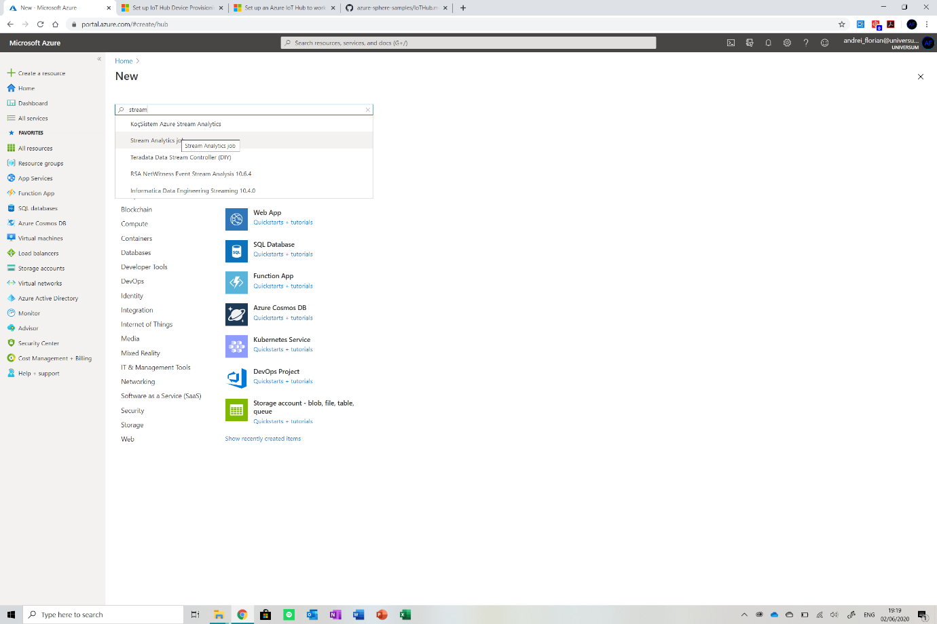

Search for *Stream Analytics* *job* and click enter. **Now set it up using the following variables**. Make sure you select the resource group used in the IoT Hub. **Ensure you reduce the units to 1 to reduce the cost.**

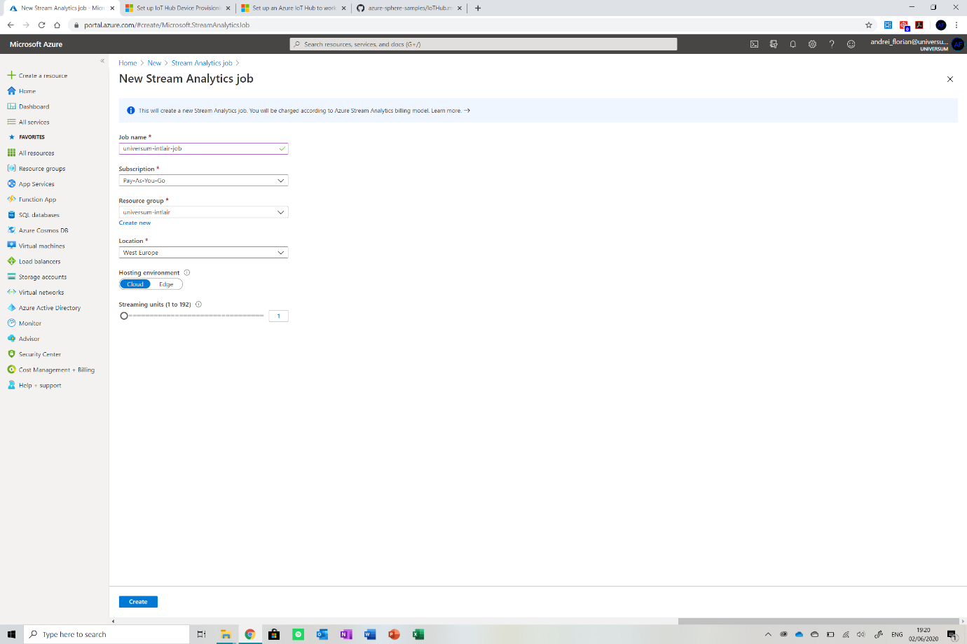

Now wait for it to deploy and then navigate over to it (pin it to your dashboard if you wish). In the resource’s menu, find *Inputs* from the item list and click on it.

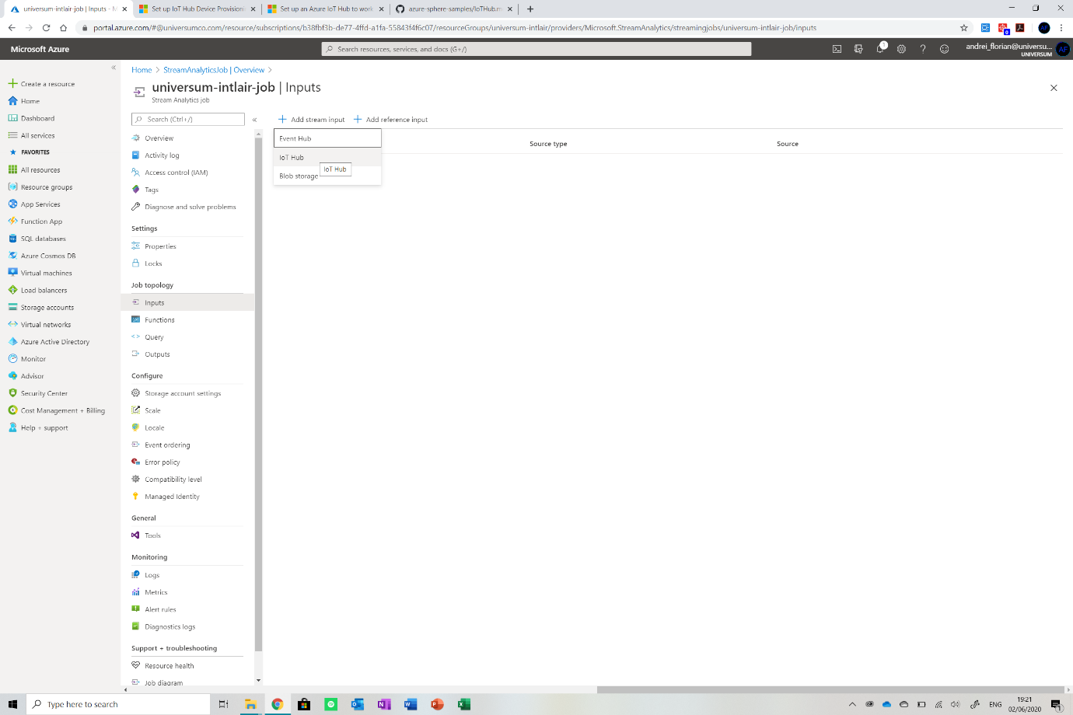

Now select the *IoT Hub* option and from the menu, choose the IoT Hub you used. **Set the resource name to *“universum-intlair-iothub”* to prevent having to change the script.** Do not change any other parameter. Click save and wait for the connection to test out. Now select the ***Outputs*** **option** from the menu (below inputs).

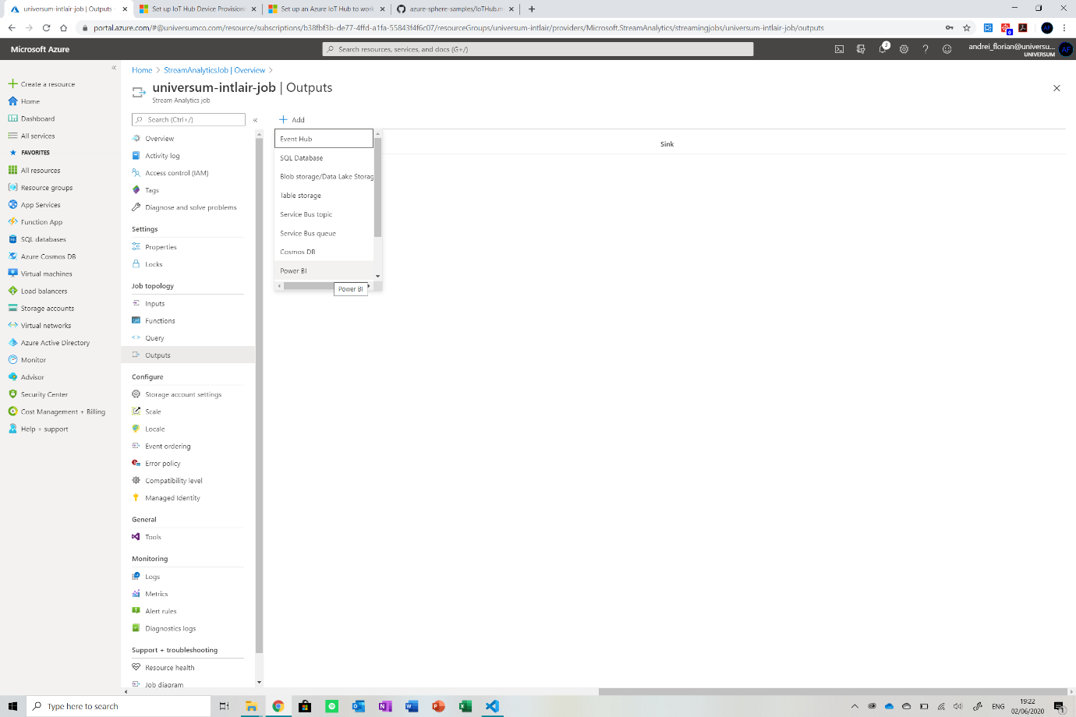

**Select the Power Bi option**. It will now prompt you to sign in. **Sign in with the Microsoft account you have with a Power Bi subscription**. If you do not own a Microsoft Business Account, use [this tutorial](https://docs.microsoft.com/en-us/power-bi/fundamentals/service-self-service-signup-for-power-bi) to create one based on your existing account for free to use this service. After that is done, ensure that all your fields match the ones shown in the image below. **Make sure you name the output *“universum-intlair-together”*.**

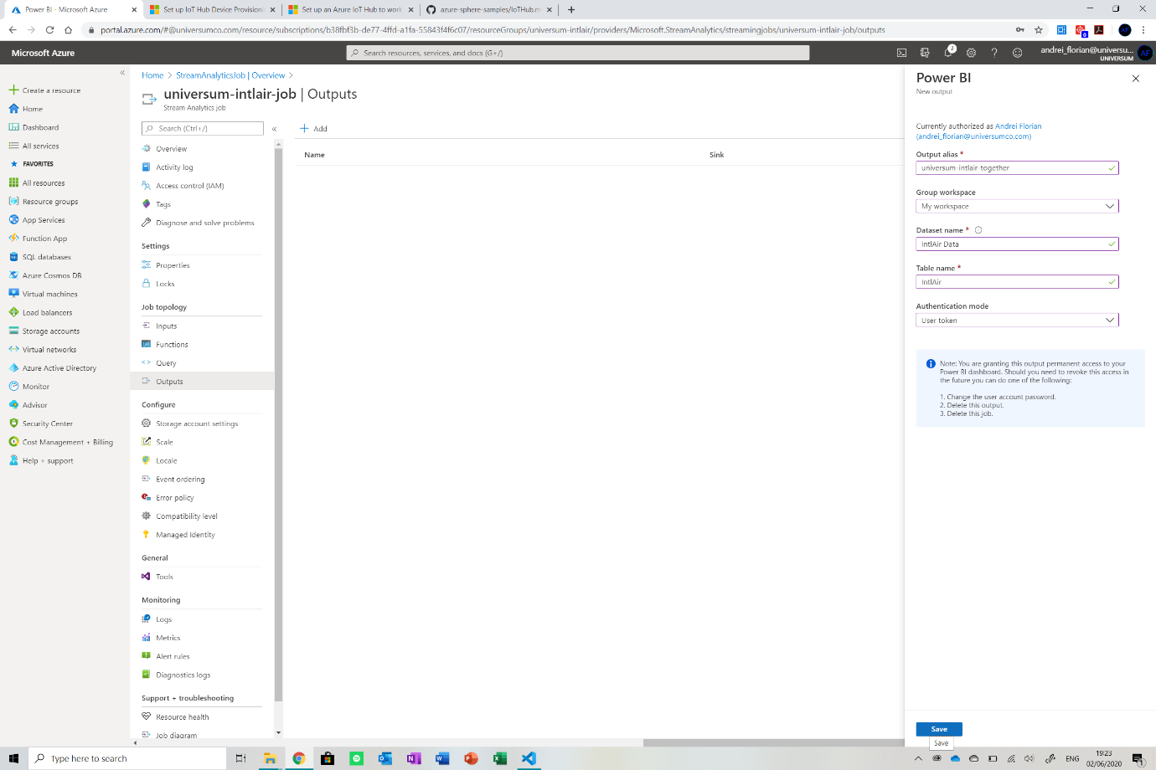

We are nearly there, now **navigate to the *Query* option** (above Outputs) and select it. Now we will have to include the script that will pull the data out of the IoT Hub and push it into the Power Bi dataset. **Copy and paste the script below in the field and then click Save Query**. **Note that if you named your input and/or output something else, you would have to edit the names in the query.**

SELECT

    co2 as co2,

    tvoc as tvoc,

    pressure as pressure,

    purifier as isPurifierOn,

    fan as isFanOn,

    time as time

INTO

    [universum-intlair-together]

FROM

    [universum-intlair-iothub]

Great! The last thing we need to do now is **start running the job**. To do this, go back to the **resource’s home page and click the run button at the top of the page**. Then select run from now and you are ready to go.

## Jumping into the Local Code

<https://github.com/Andrei-Florian/IntlAir>

**The code can be obtained from my GitHub repo** [**here**](https://github.com/Andrei-Florian/IntlAir), please pull the files and open the folder in the Visual Studio IDE to get started. Ok, let us look at the code. It is a bit messy because I had to copy a dependency into the main file because it would not work otherwise. Below I will describe the function of the main sections of code.

static void CheckTimeSyncState(void) // check if the time is synched on the device to the cloud

{

    bool isTimeSyncEnabled = false;

    int result = Networking_TimeSync_GetEnabled(&isTimeSyncEnabled);

    if (result != 0)

    {

        Log_Debug("[setup] ERROR: Networking_TimeSync_GetEnabled failed: %s (%d).\n", strerror(errno), errno);

        return;

    }

    // If time sync is enabled, NTP can reset the time

    if (isTimeSyncEnabled)

    {

        println("[setup] RTC online synch is enabled");

    }

    else

    {

        println("[setup] RTC online synch is disabled");

    }

}

void processTime(void) // get the current time

{

    int result = setenv("TZ", "PST-1", timeZone); // check if time zone is appropriately set CHANGE

    if (result == -1)

    {

        Log_Debug("[loop] ERROR: setenv failed with error code: %s (%d).\n", strerror(errno), errno);

        errorLED();

        exit(EXIT_FAILURE);

    }

    else

    {

        tzset(); // call this to synch time

        // setup for getting time

        time_t     now;

        struct tm  ts;

        memset(tbuf, 0, 32);

        // Get current time

        time(&now);

        // Format time, "ddd yyyy-mm-dd hh:mm:ss zzz"

        ts = *localtime(&now);

        strftime(tbuf, sizeof(tbuf), "%Y-%m-%dT%H:%M:%S.0Z", &ts); // Power Bi standard format

        Log_Debug("[loop] Time Local  %s \n", tbuf);

    }

}

Ok, so this first section will take care of getting the current time from the time server to which the device automatically connects when it is running. We need to send the time to the cloud because we cannot afford delays between the sends and the timestamp attached to the payload.

static void SendTelemetry(int val1, int val2, float val3, int bool1, int bool2, char* time) // send telemetry to IoT Hub

{

    static char eventBuffer[110] = { 0 };

    static const char* EventMsgTemplate = JSONBuffer;

    int len = snprintf(eventBuffer, sizeof(eventBuffer), EventMsgTemplate, "co2", val1, "tvoc", val2, "pressure", val3, "purifier", bool1, "fan", bool2, "time", time);

    if (len < 0)

        return;

    Log_Debug("[loop] Sending IoT Hub Message: %s\n", eventBuffer);

    bool isNetworkingReady = false;

    if ((Networking_IsNetworkingReady(&isNetworkingReady) == -1) || !isNetworkingReady) {

        Log_Debug("[loop] WARNING: Cannot send IoTHubMessage because network is not up.\n");

        return;

    }

    IOTHUB_MESSAGE_HANDLE messageHandle = IoTHubMessage_CreateFromString(eventBuffer);

    if (messageHandle == 0) {

        Log_Debug("[loop] WARNING: unable to create a new IoTHubMessage\n");

        return;

    }

    if (IoTHubDeviceClient_LL_SendEventAsync(iothubClientHandle, messageHandle, SendMessageCallback,

        /*&callback_param*/ 0) != IOTHUB_CLIENT_OK) {

        Log_Debug("[loop] WARNING: failed to hand over the message to IoTHubClient\n");

    }

    else {

        Log_Debug("[loop] INFO: IoTHubClient accepted the message for delivery\n");

    }

    println("");

    IoTHubMessage_Destroy(messageHandle);

}

This function will take the string that it has to send to the IoT hub and queue it. The device will then send it when it is ready.

int getAirQuality(void) // get the air quality reading from the module

{

    // variables to store readings in

    int co2temp = 0;

    int tvoctemp = 0;

    println("[loop] Getting Air Quality");

    println("[loop] Calibrating sensor");

    // warm up the sensor by reading 5 times but not storing

    for (int i = 0; i < 5; i++)

    {

        // initialise variables to work with

        uint8_t buff[2] = {};

        int32_t retVal = 0;

        uint8_t sgp30_buffer[6] = {};

        buff[0] = 0x20;

        buff[1] = 0x08;

        // communicate with module

        retVal = I2CMaster_Write(i2cFd, 0x58, buff, 16);

        sleep(1);

        retVal = I2CMaster_Read(i2cFd, 0x58, sgp30_buffer, 6);

        delay(600);

        blinkLED();

    }

    println("[loop] Getting Air Quality");

    // get the values

    for (int i = 0; i < 5; i++)

    {

        // initialise variables to work with

        uint8_t buff[2] = {};

        int32_t retVal = 0;

        uint8_t sgp30_buffer[6] = {};

        buff[0] = 0x20;

        buff[1] = 0x08;

        // communicate with module

        retVal = I2CMaster_Write(i2cFd, 0x58, buff, 16);

        sleep(1);

        retVal = I2CMaster_Read(i2cFd, 0x58, sgp30_buffer, 6);

        co2temp += (sgp30_buffer[0] << 8) | sgp30_buffer[1];

        tvoctemp += (sgp30_buffer[3] << 8) | sgp30_buffer[4];

        Log_Debug("[loop] Values Read: CO2 %d, TVOC %d  \n", co2temp, tvoctemp);

        if (retVal < 0)

        {

            Log_Debug("[loop] ERROR at getAirQuality(): : errno=%d (%s)\n", errno, strerror(errno));

        }

        blinkLED();

        delay(600); // a delay between reads

    }

    // find the average

    co2 = (co2temp / 5); // divide by 5 because read 5 times

    tvoc = (tvoctemp / 5); // divide by 5 because read 5 times

    println("");

    Log_Debug("[loop] Final co2 %d \n", co2);

    Log_Debug("[loop] Final tvoc %d \n", tvoc);

    println("");

}

void getPressure(void) // get the barometric pressure from the onboard sensor

{

    uint8_t reg;

    lps22hh_reg_t lps22hhReg;

    println("[loop] Getting Atmospheric Pressure");

    // Initialize the data structures to 0s.

    memset(data_raw_pressure.u8bit, 0x00, sizeof(int32_t));

    memset(data_raw_temperature.u8bit, 0x00, sizeof(int16_t));

    if (lps22hhDetected)

    {

        lps22hh_read_reg(&pressure_ctx, LPS22HH_STATUS, (uint8_t*)&lps22hhReg, 1);

        //Read output only if new value is available

        if ((lps22hhReg.status.p_da == 1) && (lps22hhReg.status.t_da == 1))

        {

            lps22hh_pressure_raw_get(&pressure_ctx, data_raw_pressure.u8bit);

            pressure_hPa = lps22hh_from_lsb_to_hpa(data_raw_pressure.i32bit);

            Log_Debug("[loop] Atmospheric Pressure: %.2f hpa\n", pressure_hPa);

        }

    }

    // LPS22HH was not detected

    else

    {

        println("[loop] ERROR: LPS22hh Module responded with an error");

        errorLED();

        exit(EXIT_FAILURE);

    }

    println("");

}

This section of code deals with getting the atmospheric pressure, TVOC and co2 levels from the sensors onboard.

int controlRelays(void) // code to turn relays on and off

{

    if (isRelayTvoc) // if the relay is on

    {

        loopNumberTvoc++;

        Log_Debug("loop tvoc %d \n", loopNumberTvoc);

        if (loopNumberTvoc > 29) // if 1 hour passed since the relay was on

        {

            loopNumberTvoc = 0;

            isRelayTvoc = false;

            isRelayTvocBlocked = true; // block for 1 hour

            // turn relay off

            relayTvoc(false);

        }

        if (tvoc_goodCount > 4) // if air was clean for 10 mins

        {

            loopNumberTvoc = 0;

            isRelayTvoc = false;

            isRelayTvocBlocked = true; // block for 1 hour

            // turn relay off

            relayTvoc(false);

        }

    }

    else

    {

        if (tvoc_badCount > 4) // if air was dirty for 10 minutes

        {

            if (isRelayTvocBlocked)

            {

                loopNumberTvoc++;

                if (loopNumberTvoc > 29) // blocked for 1 hour

                {

                    isRelayTvocBlocked = false; // unblock

                }

            }

            else

            {

                isRelayTvoc = true;

                loopNumberTvoc = 0;

                // turn relay on

                relayTvoc(true);

            }

        }

    }

    if (isRelayCo2) // if the relay is on

    {

        loopNumberCo2++;

        Log_Debug("loop co2  %d \n", loopNumberCo2);

        if (loopNumberCo2 > 29) // if 1 hour passed since the relay was on

        {

            loopNumberCo2 = 0;

            isRelayCo2 = false;

            isRelayCo2Blocked = true; // block for 1 hour

            // turn relay off

            relayCo2(false);

        }

        if (co2_goodCount > 4) // if air was clean for 10 mins

        {

            loopNumberCo2 = 0;

            isRelayCo2 = false;

            isRelayCo2Blocked = true; // block for 1 hour

            // turn relay off

            relayCo2(false);

        }

    }

    else

    {

        if (co2_badCount > 4) // if air was dirty for 10 minutes

        {

            if (isRelayCo2Blocked)

            {

                loopNumberCo2++;

                if (loopNumberCo2 > 29) // blocked for 1 hour

                {

                    isRelayCo2Blocked = false; // unblock

                }

            }

            else

            {

                isRelayCo2 = true;

                loopNumberCo2 = 0;

                // turn relay on

                relayCo2(true);

            }

        }

    }

}

This final function will check to see if the relays should be turned on and if they should be turned off.

## Setting up the Variables

Now that we looked at the code, we will need to **edit some variables to enable the device to connect to our IoT Hub.** Before we get started, make sure the **app_manifest.json file is open in Visual Studio.**

The first thing we must do is **open the Azure Sphere command prompt**. This is done by pressing the Windows button and typing *azsphere*. Make sure you are signed in with your account and the correct tenant is selected. **Type the following command to get your tenant ID.**

Azsphere tenant show selected

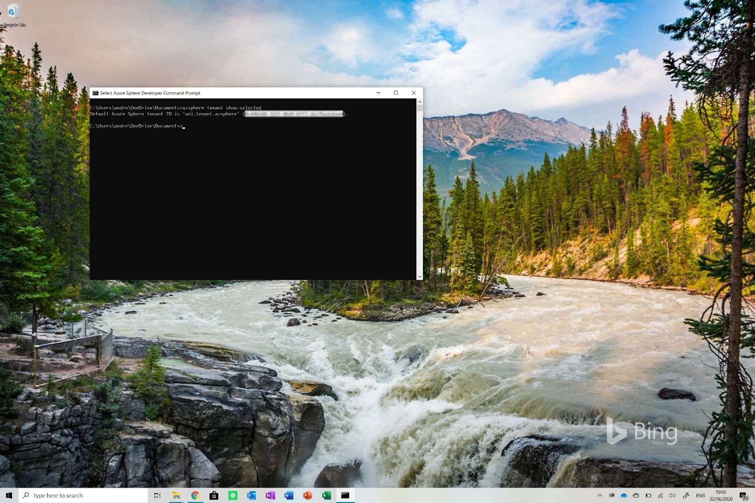

You should see something like this in your window. Co**py the tenant ID that is displayed and go to your code. Paste it in the *DeviceAuthentication* field.**

Now navigate to your Azure Portal and **open the IoT hub** the device is connected to. Copy and paste the **hostname field on the main page into the *AllowedConnections*** filed in the application manifest**.**

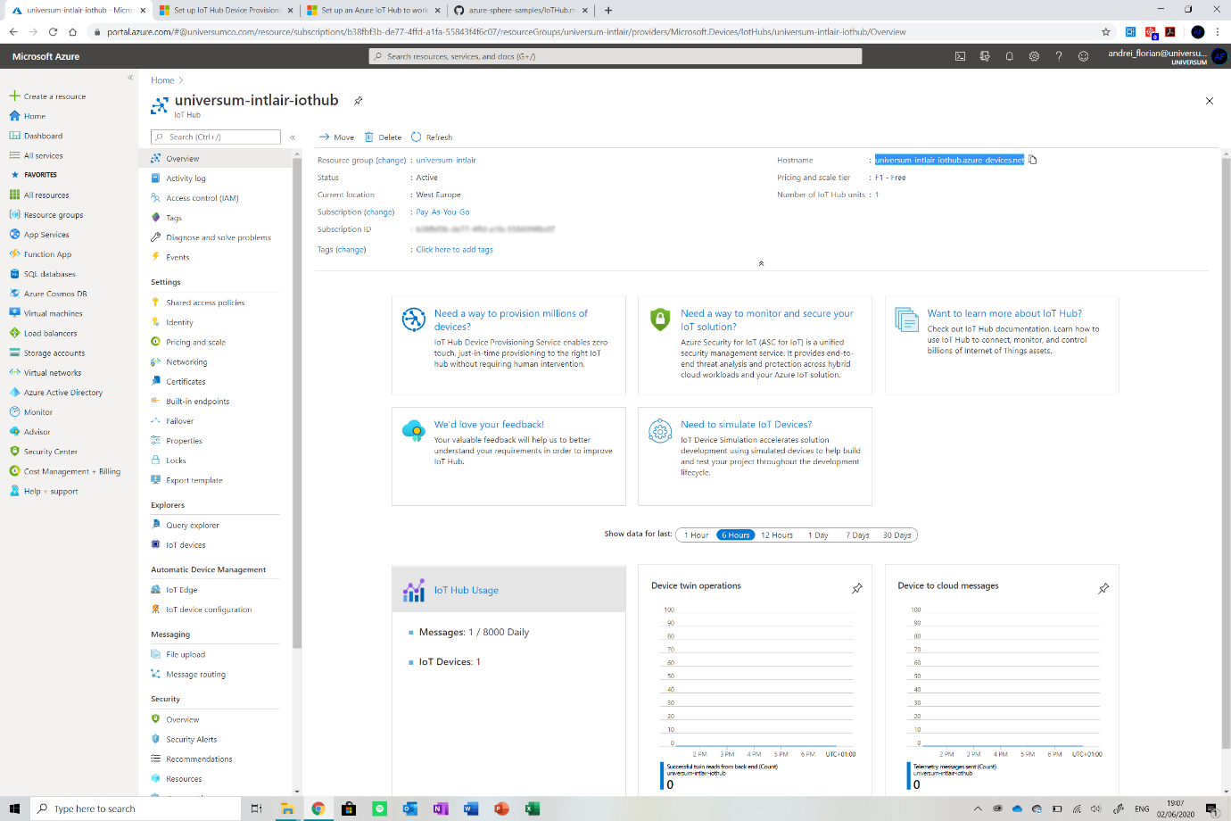

Finally, navigate to your **DPS and copy and paste the *ID Scope* field** displayed on the main page into the ***CmdArgs*** **field** in the application manifest. You are now ready to go!

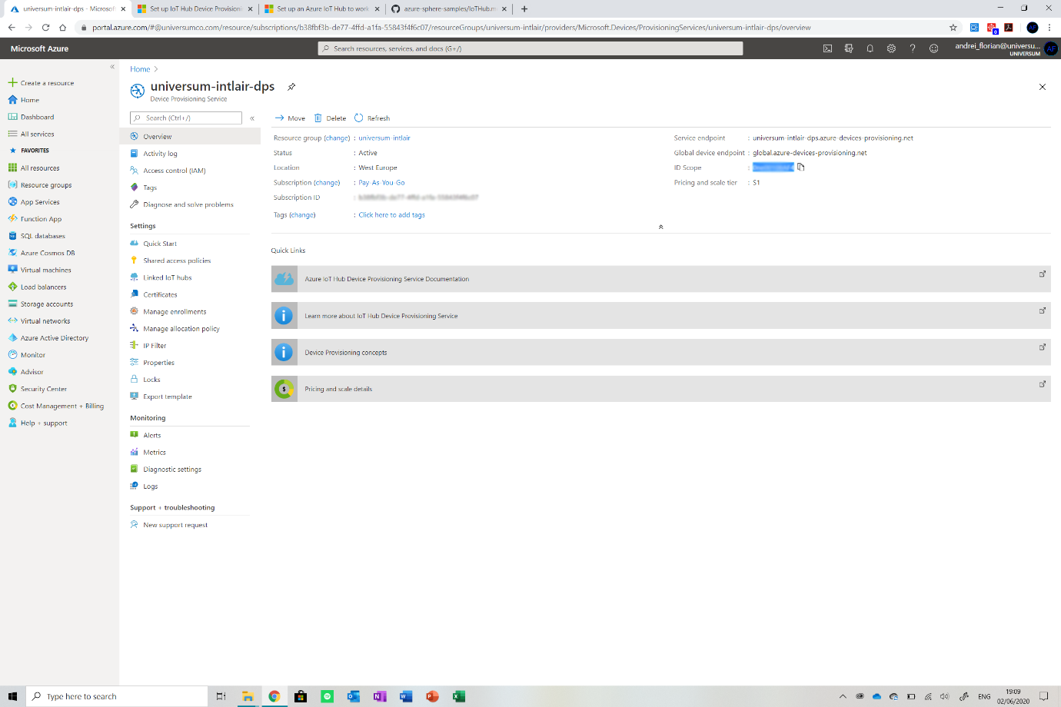

## Flashing the Code

Now that all of that is done. **We must flash the application to the device**. **Connect the Azure Sphere device to your PC and then select the *HighLevelCore*** from the flash options and click the run application button in the Visual Studio IDE.

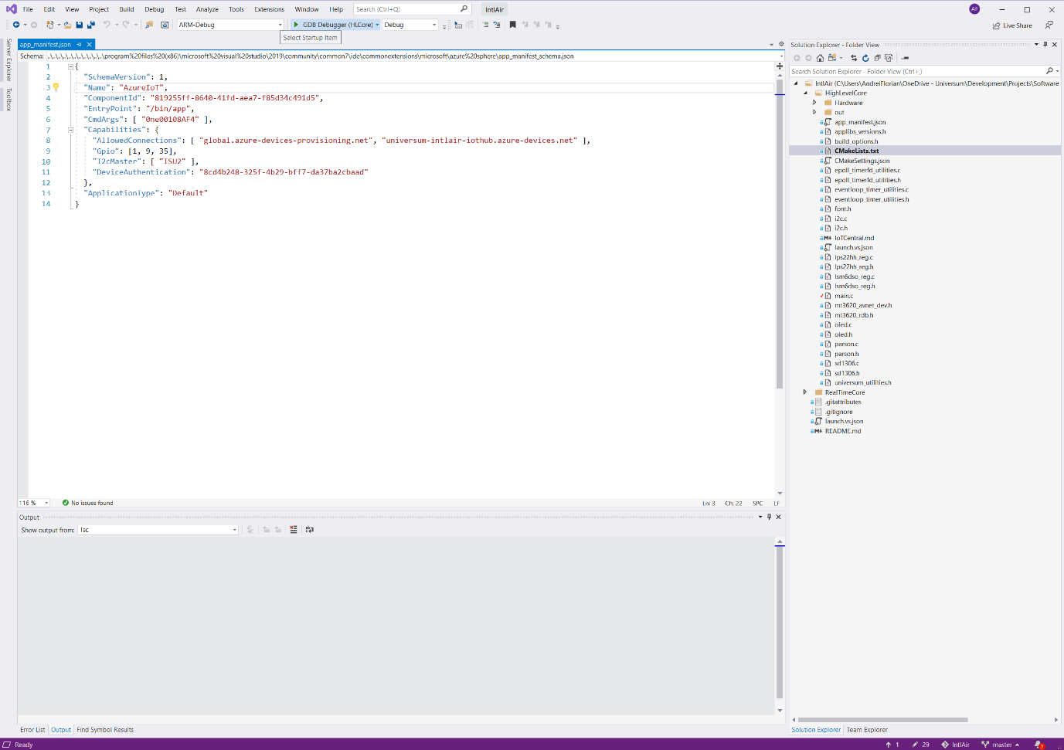

Now before you use the product for distribution, please follow [this tutorial](https://docs.microsoft.com/en-us/azure-sphere/deployment/deployment-concepts) to get the application running on the device in release mode.

## Mounting Everything

For the sake of this prototype, I did not create a case or enclosure for the device. In most cases, the device can be hid away somewhere, I decided to put it behind the air purifier But you could put it somewhere on the wall if that’s better, probably if you do enclose it.

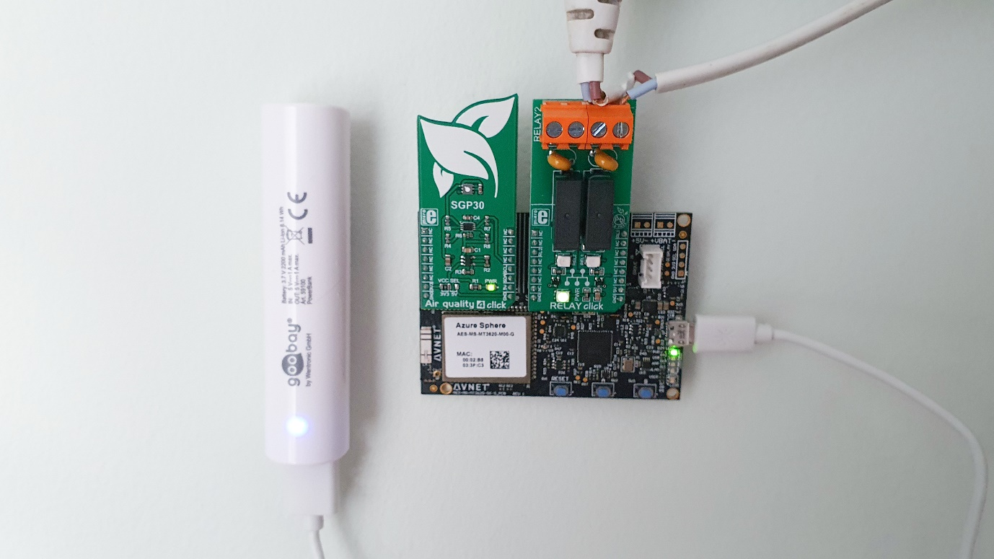

## Finally, let’s work on the dashboard!



The last thing we need to do is **get the dashboard ready to go**. The first thing we need to do is open the Power Bi app (get it on the Windows store if you do not already have it, you can also use the web app). Create a new report and click on the Get Data button.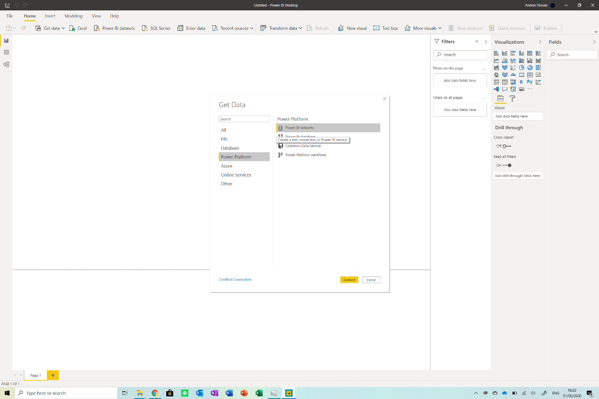

**Navigate over to the Power Platform** and then select **Power Bi datasets**. Now simply select the dataset we have (**make sure you ran the code for a while before, so we have data available**). The data should now be ready to go.

Ok, on to the frustrating part, we now have to **create a dozen measures** or so for the project. I will guide you through making one and you will have to **repeat the process for the rest**. **To get started, make sure you have the expressions folder open (from the GitHub repo you downloaded earlier).** You will see a dozen or so expressions there, we need to create new measures based on those scripts.

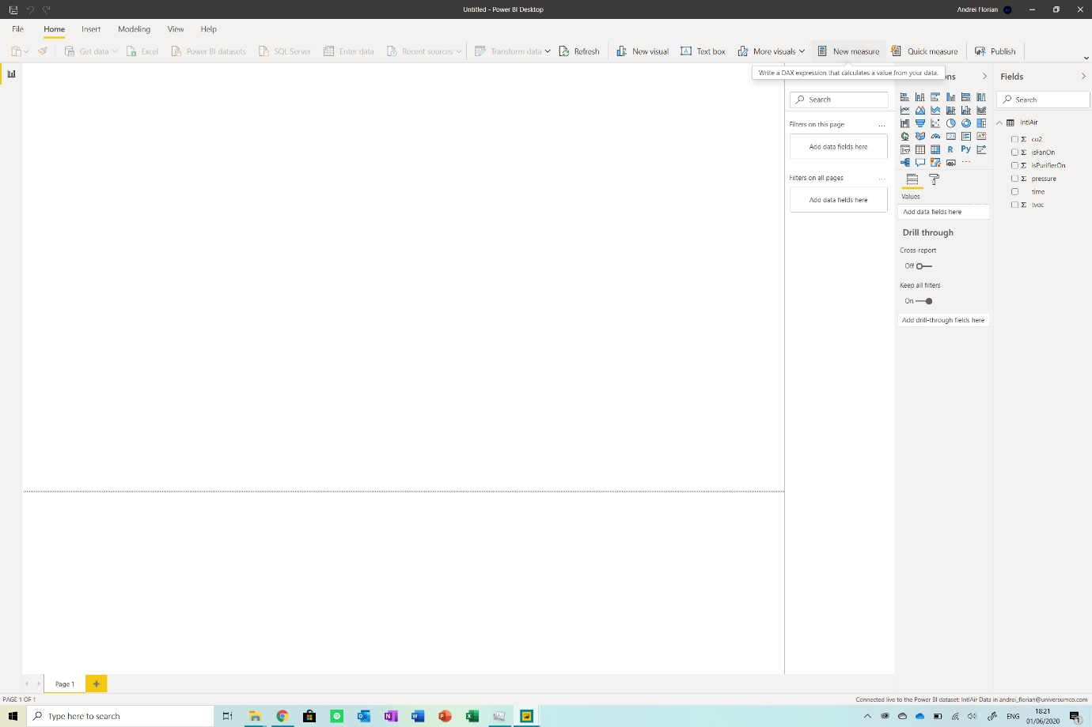In Power Bi, navigate to the menu bar at the top of the screen and select the *New Measure* button. This should **create a new measure and give you a text box**. Now **open any one of the files** (you can open them in VS code or a lightweight editor) and **copy and paste the content into the box**.

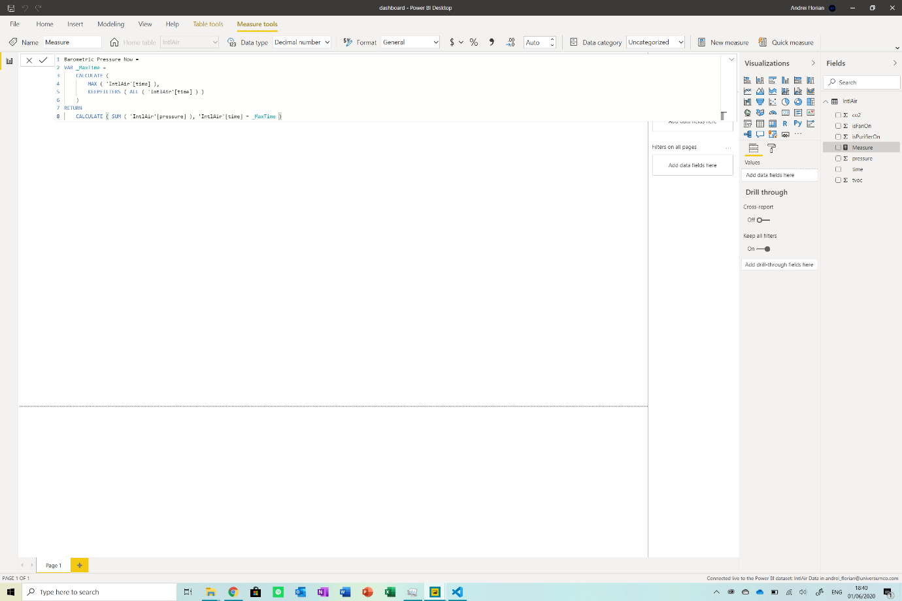

Ok, so now **repeat this process for all the values**, **do not worry if errors appear**, once you do not edit the scripts, everything should be fine at the end. After you added all the scripts, your report should look something like this:

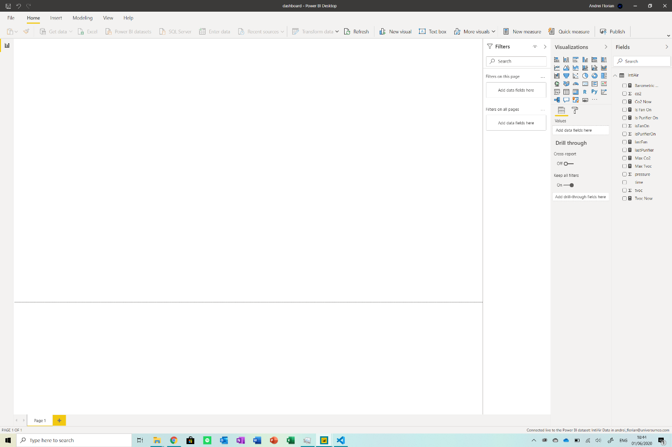

Now we can get to the fun stuff, this [link](https://docs.microsoft.com/en-us/power-bi/fundamentals/service-get-started) from Power Bi will show you how to get started with creating stunning visuals on the platform. This is my product:

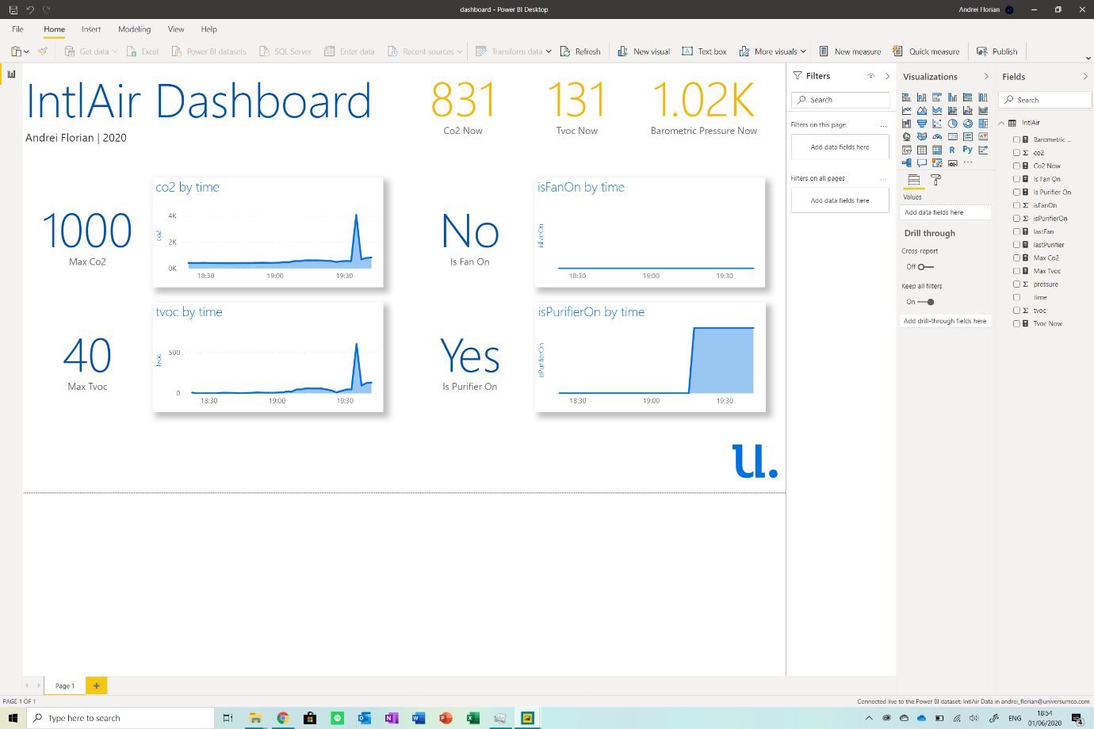

Now click on the *View option* from the top nav bar and select *mobile layout*. Drag and drop the graphs and text onto the phone frame to **create a mobile version of the dashboard**. Mine looked like this:

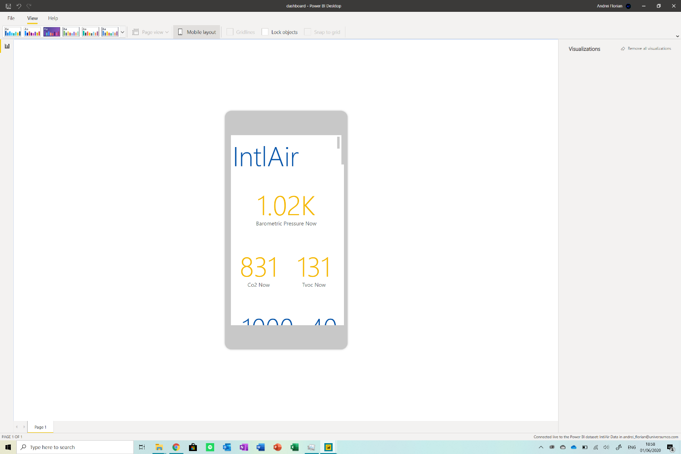

Ok, so finally go back to the home page on the app and click on the *Publish Report* button from the options. **This will publish your dashboard to the web allowing you to access it from anywhere**. Just log into Power Bi and you should see it there. That is it, we are done!

Make sure to get the Power Bi app, it is available on Google Play and the App Store.

# Reflection

I really enjoyed working on this project. I remember seeing the contest a while ago (like 1 month ago) and starting to brainstorm ideas. I soon got to IntlAir, an air purification system and got to work. Because I participated in prior contests with this device, I started developing the idea and coding the project immediately.

It took me about a month to finalise all details and test the device thoroughly. Here I am now with a smart air purifier in my home. I did have some surprises along the way, namely about the levels of TVOCs in the house, which really showed me the importance of IntlAir and the impact it can have.

Most people do not even know if the air in their homes is clean or not, let alone purify it. I developed IntlAir to empower people with this data at a low cost and allow them to live in a clean, safe environment. I hope you enjoyed the read! If you have any questions or need help building the project, drop me an email at [Andrei_florian@universumco.com](mailto:Andrei_florian@universumco.com).

